Station 1: Diving Paper

Problem: Does air take up space?

Prediction/Hypothesis: What do you think will happen? Why?

________________________________________________________________________

________________________________________________________________________

________________________________________________________________________

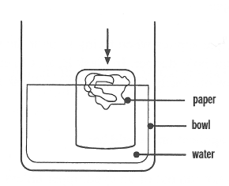
Materials:
- Sheet of paper
- Glass cup
- Bowl filled with water

Procedure:
- Crumple up the piece of paper and push it into the bottom of the glass.
- Turn the glass over and push it straight down into the bowl of water.
- See what happens to the sheet of paper.

Observations: What did happen?

________________________________________________________________________

________________________________________________________________________

________________________________________________________________________

Inference: Why did this happen?

________________________________________________________________________

________________________________________________________________________

________________________________________________________________________

Station 2: Huff N’ Puff

Problem: Does air take up space?

Prediction/Hypothesis: What do you think will happen? Why?

________________________________________________________________________

________________________________________________________________________

________________________________________________________________________
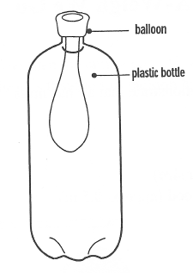
Materials:
- Deflated balloon
- Plastic pop bottle

Procedure:
- Push the deflated balloon into the bottle and stretch the open end of the balloon back over the bottle’s mouth.
- Without removing the balloon from the bottle, try and blow it up.
- See what happens to the balloon.

Observations: What did happen?

________________________________________________________________________

________________________________________________________________________

________________________________________________________________________

Inference: Why did this happen?

________________________________________________________________________

________________________________________________________________________

________________________________________________________________________

Station 3: A Balancing Act

Problem: Does air have mass?

Prediction/Hypothesis: What do you think will happen? Why?

________________________________________________________________________

________________________________________________________________________

________________________________________________________________________
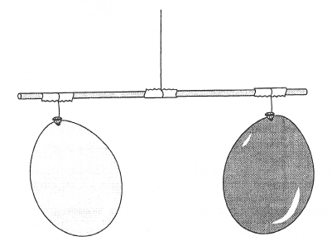
Materials:
- Two same-sized balloons
- Meter stick
- String
This one should be deflated
- Two pieces of tape

Procedure:
- Tightly tie the string around the meter stick.
- Tie the other end of the string to a cupboard handle so the stick swings freely.
- Move the string along the meter stick until it is balanced.
- Tape a deflated balloon to one end of the meter stick.
- Blow a large amount of air into the other balloon and tie it shut and tape it to the other end of the meter stick.
- See what happens to the balance.

Observations: What did happen?

________________________________________________________________________

________________________________________________________________________

________________________________________________________________________

Inference: Why did this happen?

________________________________________________________________________

________________________________________________________________________

________________________________________________________________________

Station 4: Raise Up Your Books

Problem: Does air exert pressure?

Prediction/Hypothesis: What do you think will happen? Why?

________________________________________________________________________

________________________________________________________________________

________________________________________________________________________

Materials:
- Large balloons
- Books

Procedure:
- Place the balloon on the edge of the desk and a pile of three heavy books on top.
- Blow into the balloon lifting the books.
- See how many books you can blow up.

Observations: What do you think will happen?

________________________________________________________________________

________________________________________________________________________

________________________________________________________________________

Inference: Why did this happen?

________________________________________________________________________

________________________________________________________________________

________________________________________________________________________

Station 5: Magic Seal

Problem: Does air exert pressure?

Prediction/Hypothesis: What do you think will happen? Why?

________________________________________________________________________

________________________________________________________________________

________________________________________________________________________

Materials:
- Manila tag
- Glass cup
- Water

Procedure:
- Fill the glass with water.
- Place the manila tag completely over the top of the glass.
- Use one hand to hold the glass, the other to hold the cardboard. Quickly, but carefully turn the glass upside down.
- Gently let go of the cardboard.
- See what happens to the cardboard.

Observations: What did happen?

________________________________________________________________________

________________________________________________________________________

________________________________________________________________________

Inference: Why did this happen?

________________________________________________________________________

________________________________________________________________________

________________________________________________________________________

