Name: ____________________________________

Parts of an Airplane Investigation

After having completed the Forces of Flight Investigation, you should now understand the relationship between lift, gravity, thrust, and drag. However, before you can learn to fly you must become an expert on the control surfaces and major components of an aircraft. Complete the tasks below to continue your journey in becoming an experienced aircraft pilot.

Use the following websites on the class page to help you complete the tasks:
- How Things Fly – Smithsonian National Air and Space Museum
- The Thrill of Flight – Learn Alberta

Task 1: Label the parts of the airplane, using the terms provided below.

fuselage vertical stabilizer elevators rudder wings
ailerons horizontal stabilizer propeller cockpit tail
engine landing gear flaps

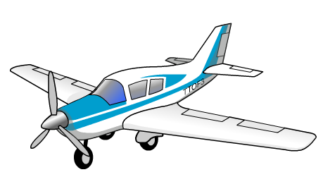

Task 2: Now that you know where the parts of an airplane are located, explain the function, or purpose, of each part.

Fuselage: ______________________________________________________

_______________________________________________________________

Cockpit: _______________________________________________________

_______________________________________________________________

Wings: ________________________________________________________

_______________________________________________________________

Tail: __________________________________________________________

_______________________________________________________________

Horizontal stabilizer: _____________________________________________

_______________________________________________________________

Vertical stabilizer: _______________________________________________

_______________________________________________________________

Elevators: ______________________________________________________

_______________________________________________________________

Rudder: ________________________________________________________

_______________________________________________________________

Ailerons: _______________________________________________________

_______________________________________________________________

Flaps: _________________________________________________________

_______________________________________________________________

Propeller: ______________________________________________________

_______________________________________________________________

Engine: ________________________________________________________

_______________________________________________________________

Landing gear: ___________________________________________________

_______________________________________________________________

Task 3: Control surfaces are moveable parts that change the flow of air past an airplane. They provide an airplane with control and stability. List all of the airplane parts from the previous tasks that are considered control surfaces.

_______________________________________________________________

_______________________________________________________________

Task 4: Draw and label the three axes that airplanes are controlled along.

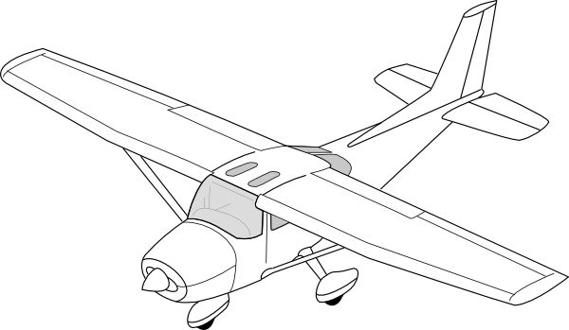

Task 5: List the three movements of an airplane, describe the movement, and identify which control surface(s) controls each movement.

Movement | Description | Control Surface(s)

Congratulations!

You have completed all the tasks and are now ready to learn how to fly!

