Paper Rotor Template

Instructions: A B

- Cut out figure along the solid lines.

- Fold in the bottom two flaps along dotted lines.

- Clip the folded flaps together using a paper clip.

- Fold the A and B in opposite directions along dotted lines.

- Stand on your chair and drop the paper rotor to the ground.

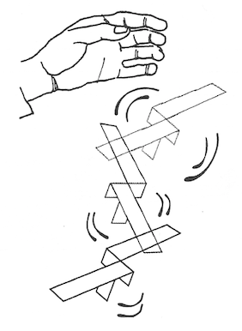

_______ = cut _ _ _ _ _ = fold

