Making Parachutes
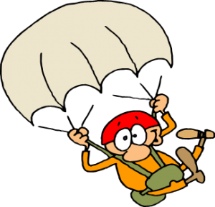

Group Members

- _________________________________

- _________________________________

- _________________________________

- _________________________________

Manipulated Variable: Canopy material

Constant Variables:
- -
- -
- -
- -

Responding Variable: ____________________________________________________

Diagram of original design: | Diagram of final design:

Test | Results | Modifications
#1

#2

#3

Manipulated Variable: Dimensions and shape of canopy

Constant Variables:
- -
- -
- -
- -

Responding Variable: ____________________________________________________

Diagram of original design: | Diagram of final design:

Test | Results | Modifications
#1

#2

#3

Manipulated Variable: Shroud line material

Constant Variables:
- -
- -
- -
- -

Responding Variable: ____________________________________________________

Diagram of original design: | Diagram of final design:

Test | Results | Modifications
#1

#2

#3

Manipulated Variable: Length of shroud lines

Constant Variables:
- -
- -
- -
- -

Responding Variable: ____________________________________________________

Diagram of original design: | Diagram of final design:

Test | Results | Modifications
#1

#2

#3

Manipulated Variable: Number of shroud lines

Constant Variables:
- -
- -
- -
- -

Responding Variable: ____________________________________________________

Diagram of original design: | Diagram of final design:

Test | Results | Modifications
#1

#2

#3

Manipulated Variable: Size of the air hole

Constant Variables:
- -
- -
- -
- -

Responding Variable: ____________________________________________________

Diagram of original design: | Diagram of final design:

Test | Results | Modifications
#1

#2

#3

Manipulated Variable: Type of load

Constant Variables:
- -
- -
- -
- -

Responding Variable: ____________________________________________________

Diagram of original design: | Diagram of final design:

Test | Results | Modifications
#1

#2

#3

Manipulated Variable: Height of drop

Constant Variables:
- -
- -
- -
- -

Responding Variable: ____________________________________________________

Diagram of original design: | Diagram of final design:

Test | Results | Modifications
#1

#2

#3

