How Hot Air Balloons Work

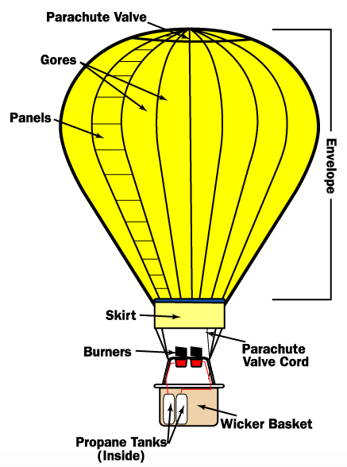
Propane gas burners, mounted _______________ the balloon, heat the air inside the balloon ___________________. Heat causes air molecules to become more _______________ and expand. Because hot air is less dense than cold air, it becomes __________________ and causes the balloon to rise. To keep the balloon aloft, a blast from the _______________ is given every thirty seconds. To lower the balloon, the pilot opens the parachute valve at the top of the balloon allowing hot air to _______________. To maneuver the balloon horizontally, the pilot ascends or descends in altitude, catching different ____________________.

Cold Air | Hot Air
More dense (air molecules are close together)  Heavier  Sinks | Less dense (air molecules are spread out)  Lighter  Rises

