How Helicopters Work

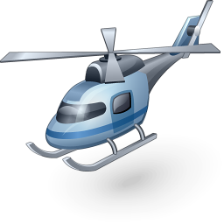

Helicopters, with their horizontal propeller called a ______________, do not require forward propulsion. Each of the long, thin blades of the rotor is shaped like an _______________. The spinning blades create an area of __________ pressure under them and an area of _______________ pressure over the top of them. This produces the lift needed to take the helicopter into the air. When the helicopter’s blades are _______________, it flies in the direction of the tilt.
If a helicopter was designed with a single rotor it would be very difficult to _______________. The rotor, spinning in one direction, sends the body twisting in the ____________________ direction. To overcome this effect, some helicopters are designed with two rotors, each turning in the ____________________ direction. This is typical of large helicopters used to carry _______________ loads. Most helicopters compensate for this twisting by adding a smaller, sideways facing rotor on the _____________. It creates an equal but opposite ____________________ force to that produced by the main rotor.

