Fingerprint Ridge Patterns

Cause of Fingerprint Patterns:
Human skin is made up of two layers: the upper layer (or epidermis) is where fingerprint ridges are found. The layer below (dermis) contains sweat glands. Sweat glands produce a salty water-based oil solution that is released from each sweat pore and coats the ridges of your upper layer of skin. The fingerprint ridges retain the sweat/body oil solution such that when the finger makes contact with any surface, residue is left behind - this is the cause of any fingerprint impression.
Superficial injuries like burns, abrasions, or cuts do not alter the fingerprint ridge pattern as the original pattern is duplicated when new skin grows in. A deep cut injury that destroys the dermis will permanently damage fingerprint ridges, causing scarring to occur. The fingerprint pattern (on right) shows scarring.

The oldest successfully lifted fingerprint came from a 2000 year-old Egyptian mummy!
Basic types of Fingerprint Patterns:
There are three basic types of fingerprint ridge patterns in humans: arches, loops and whorls.
LOOPS: approx. 60% of North Americans exhibit this pattern - lines that rise, curve and return.
WHORLS: approx. 34% of North Americans have this pattern - lines form concentric circles, whirlpools or spirals.
ARCHES: approx. 5% of North Americans exhibit this pattern - lines cross smoothly go upwards at center.
COMPOSITE: approx. 0.5-1% of North Americans exhibit this pattern (rarest) – it’s a combination of the above.
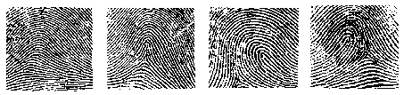

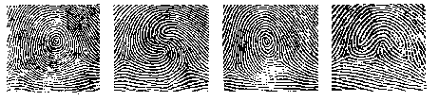

Every human has had the same fingerprint pattern since birth. The only difference between a child’s print and an adult print is that the fingerprint ridges of a child are closer together.

